Florida Mission and Vision
VISION: Provide information, leadership and guidance to the Florida military community and legislature promoting a partnership between higher educational institutions and government entities to ensure a quality higher education environment

MISSION: The Florida Advisory Council on Military Education (FL ACME) is a member-driven organization that serves as a liaison between Department of Defense, state and federal Departments of Veteran Affairs, and Florida based institutions of higher learning to promote, support, and deliver quality educational and professional opportunities for all Florida based military affiliated personnel by providing innovative and ethical provisions for higher educational institutions, government and state entities. FL ACME advocates and promotes delivery of meaningful higher education and provides appropriate educational resources for all Florida military affiliated adult learners.

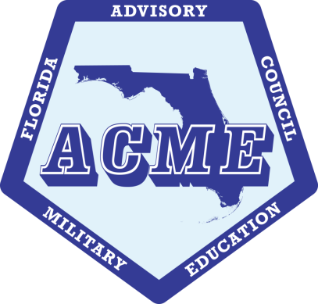

Webpage: http://fla-acme.org
Facebook: https://www.facebook.com/FL.ACME
Mailing Address: PO Box 3456
Riverview, FL 33568

Email: floridaacme@gmail.com
Twitter: FloridaACME
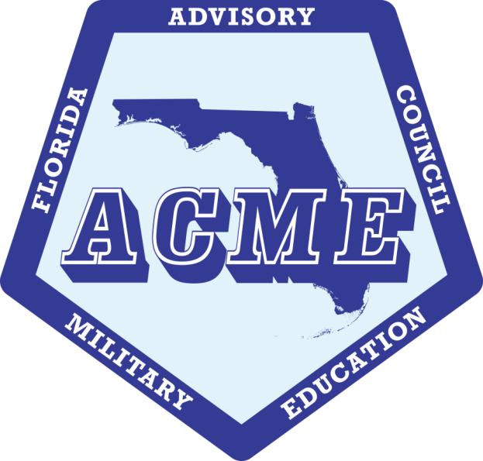

Florida Advisory Council on
Military Education (FL ACME) Workshop
April 29 – 30, 2019
“Discovering Educational Treasures on the Emerald Coast”

Fort Walton Beach, FL
Home of Eglin Air Force Base and
Hurlburt Field

FL ACME Board Members

Vice President
Aaron Hall
Full Sail University 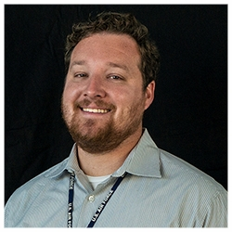
President
Keith Davis
American Military University
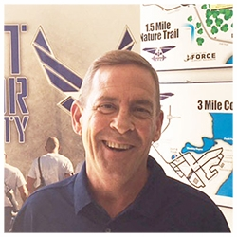
Past President
Willie Woolford
Bellevue University
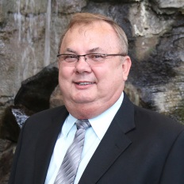

Treasurer
George Colon
Grantham University
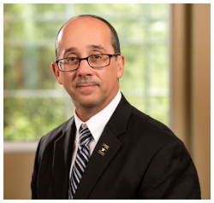

Secretary
Vacant

Sponsors

Platinum
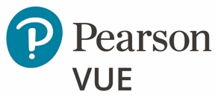
Gold
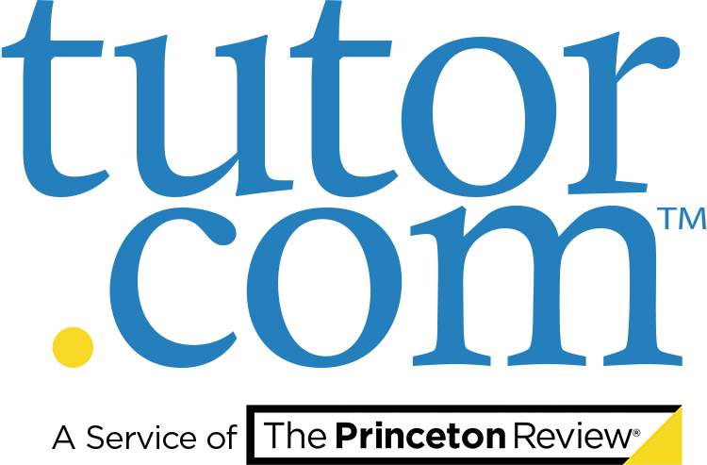
Silver
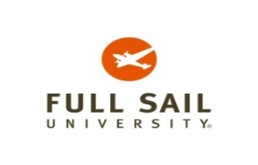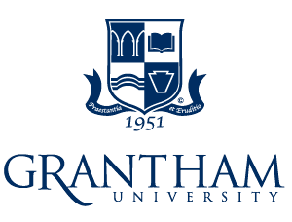

Presenters
- Navy College Office– The new Navy College Program website is a resource for everyone, including "Academic Institutions". It provides direct access to processes and policies involved with voluntary education. https://www.navycollege.navy.mil/information-for-academic-institutions/index.htm

- Pearson VUE – the global leader in computer-based testing for high-stakes certification and licensure. Deliver over 5400 certification exams offered by credentialing organizations at your base-sponsored National Testing Center, joining 350 Pearson VUE on base locations supporting workforce professionalization, and accelerate transition success. www.pearsonvue.com/military

- CMA – Centurion Military Alliance serves as a nationwide nonprofit organization in support of the Department of Defense (DOD) Transition Assistance Program (TAP) and peripheral DOD duly-authorized program(s). https://cmawarrior.org/

- NAVPA – The National Association of Veterans’ Program Administrators is an organization of institutions and individuals who are involved or interested in the operation of veterans' affairs programs and/or the delivery of services to veterans as school certifying officials across the country. http://www.navpa.org/

- Tutor.com – Named by the Today Show as a Top 5 Education App, Tutor.com is available 24/7 to our military members at no cost. Tutor.com for U.S. Military Families is funded by the U.S. Department of Defense and Coast Guard Mutual Assistance. Also the 2017 CCME Corporate Award Winner. www.tutor.com/

- DANTES – The Defense Activity for Non-Traditional Education Support (DANTES) manages a portfolio of Defense education programs that help service members achieve their education goals and earn degrees or certifications both during and after their service. www.dantes.doded.mil/

Welcome Message
Florida ACME President – On behalf of the Florida ACME Board, thank you for your support of the Florida Advisory Council on Military Education and welcome to our Workshop. Please use this opportunity to network and share best practices with others, but also promote the vision of our ACME. Our theme this year is: “Discovering Educational Treasures on the Emerald Coast.”

Area History
Fort Walton Beach is a small city in the Florida Panhandle. It’s known for fine white-sand beaches on adjacent Okaloosa Island. The island’s Gulfarium Marine Adventure Park is home to dolphins, penguins and alligators. The Indian Temple Mound Museum includes the prehistoric Temple Mound and Native American artifacts. Northeast, the Air Force Armament Museum displays artifacts and aircraft from WWI to the present.
Destin is a city in northwest Florida, in the area known as the Panhandle. It's known for its Gulf of Mexico beaches and many golf courses, as well as the Destin Harbor Boardwalk. Nature trails pass through the dunes of Henderson Beach State Park in the south, where the coastline is dotted with pine and oak trees sheltering wildlife. To the west are the tall slides, waterfalls and pools of Big Kahuna’s water park. Every October, Destin Harbor hosts the Fishing Rodeo attended by fishermen from around the world.

FL ACME History
(Provided by Dr. Gary Woods, former Chief, DoD Voluntary Education)
In July 1982, Dr. Jerry Robbins, Associate Vice President of Academic Affairs at Georgia State University, welcomed those participating in the Department of Defense/Department of Education Conference on the Establishment of State Advisory Committees on Military Education.
Dr. Israel Tribble, Director of Voluntary Education in the Office of the Deputy Assistant Secretary of Defense, then gave a brief overview of the totals and purpose of the conference. He noted that, as competition for student’s increases, there is a need for an informal yet organized method of facilitating communication, among state agencies, institutions, and the military services to avoid conflicts and learn how to service most efficiently the needs of the military.
He stated that an effective model for dealing with the problems associated with voluntary off-duty education to military personnel is an Advisory Council on Military Education — one such organization has been operating in Florida the past several years.
Dr. C. Wayne Freeberg, Executive Director of the Florida Board of Independent Colleges and Universities (FBICU), described the formation of the Advisory Council on Military Education (ACME) following a conference in Tallahassee in November 1978.
The conference was held in response to the Education Commission of the States Tack Force on “State Institutional and Federal Responsibilities in Providing Postsecondary Educational Opportunities to Service Personnel,” and one of the recommendations was the states take on greater responsibility in the provision of such services.
Dr. Freeberg recommended that the states, using a vehicle such as ACME, should assist the military, accreditation agencies, state licensing agencies and the Institutions in their efforts to insure that voluntary education programs are of high quality. Based on the Florida model, he outlined the framework of the council.
The Florida ACME is the one of the first ACMEs created among the current 11 ACMEs (covering 18 states), and 2019 marks its 41st year in existence. Your FL ACME received the 2019 Gary A. Woods Award as best ACME!
Presenters
- National Anthem – SrA Ashley Reaves, Hurlburt Field

- Invocation – Chaplain Martin Lister, Eglin AFB

- CC Welcome – Col Ivory Carter, 96th MSG/CC
CC Welcome – Col Gary Dorman, 1st SOMSG/CC

- Compete Florida Military – Complete Florida Military is a state legislatively funded initiative to help current military, veterans and their families’ complete degrees and IT certifications. We partner with 15 Florida institutions offering over 90 online degree programs, concierge based coaching and scholarships. completefloridamilitary.org

- DoD Voluntary Education – presentation by Dr. Johnathan Woods, Acting, DoD Voled Chief

- CCAF – The Community College of the Air Force is a federally-chartered degree-granting institution that serves the USAF’s enlisted total Force. The college annually awards over 22,000 associate in applied science degrees from 71 degree programs. https://www.airuniversity.af.edu/Barnes/CCAF/

- VSOC - The VSOC program provides a VA Vocational Rehabilitation Counselor (VRC) to each VSOC school. These VRCs are called VetSuccess on Campus (VSOC) Counselors. https://www.benefits.va.gov/vocrehab/vsoc.asp

- Military One Source – Military OneSource is your central hub and go-to-place for the military community. Get to know your benefits and prepare for the big stuff – deployments, reintegration, moves, parenthood, retirement and more. www.militaryonesource.mil/

- NAIMES – Advocates for the military student and partners with the military education community for the betterment of off-duty Voluntary Education programs. http://naimes.org

Key Note Speaker
Key Note
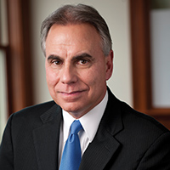
Speaker

Mr. Jim Sweizer

Jim Sweizer has an extensive 34-year management background in adult continuing education having served as a guidance counselor and education services officer at a variety of overseas and stateside military installations, and was named chief of the Air Force’s Voluntary Education Program in 1999. In this capacity, he was responsible for the development and implementation of policy for off-duty voluntary education, dependent education and veterans’ benefit programs, and also managed the Air Force Tuition Assistance Program.
After retiring from the Air Force in 2005, Jim joined American Military University (AMU) where he managed all military, community college and veterans outreach activities, and served as the main liaison between the university and Department of Defense agencies until his “second” retirement 2015.
He previously served as chair of the University Professional and Continuing Education Association’s (UPCEA) Military Division; President, Council of College and Military Educators (CCME); Chair, Policy and Issues Committee for the National Association of Institutions for Military Education Services (NAIMES); and Director, Commission for Military Education and Training of the American Association for Adult Continuing Education (AAACE).
He is a graduate of the Air War College non-resident program and Harvard University’s Institute for the Management of Lifelong Education (MLE).
He now lives in Rehoboth Beach, Delaware during the summer months and Orange Park, Florida during the winter with his spouse Valerie. They totally embrace this lifestyle, better known as “snowbirds”.
Pre-Workshop Events

Sunday, April 28, 2019
1600 - 1700 | FL ACME Board Meeting (Location – Hilton Garden Inn)
1700 - 1800 | Hotel Check-in (Early Registration in hotel lobby)

Post-Workshop Events

Wednesday, May 1, 2019
0900 - 1500 | Eglin AFB, Education Fair
1500 - 1700 | Community Service Project – DAV, Niceville, FL
Thursday, May 2, 2019
1000 - 1400 | Hurlburt Field, Education Fair
Friday, May 3, 2019
1000 - 1400 | Tyndall AFB, Education Fair

Agenda – Day One

Monday, April 29, 2019
0700 - 0800 | Networking Breakfast/Workshop Registration Continued
0800 - 0810 | Colors Presentation/National Anthem/Invocation
0810 - 0815 | Opening Remarks/Introduce Base Welcome Rep –  FL ACME President Keith Davis
0815 - 0830 | Welcome – Eglin AFB and Hurlburt Field Commanders
0830 - 0835 | Keynote speaker Introduction
0835 - 0935 | Keynote speaker – Mr. Jim Sweizer
0935 - 0950 | Break
0950 - 1030 | NAVPA/FL Legislative Update – Dr. Jan Del Signore
1030 - 1100 | Tutor.com – Ms. Pamela Brehm
1100 - 1230 | Working Lunch with Navy College updates – LCDR Adam Walski  AF Updates – Ms Lisa Splinter and Army Updates - MSGT Peterson
1230 - 1315 | DANTES – Dr. Jeff Allen
1315 - 1345 | CCAF Update – Mr. Steve Mihal
1345 - 1430 | By-laws Review/Committee Updates – Aaron Hall
1430 - 1445 | Scholarship Presentations – George Colon, Treasurer
1445 - 1500 | Break
1500 - 1545 | NAIMES Update – Mr. John Aldrich
1545 - 1600 | Election reminder, announcements and wrap up  Day One of Workshop
1700 - 1830 | President’s Reception (Hilton Garden Inn, Beach)
1830 - 2000 | Optional evening event

Agenda – Day Two
Tuesday, April 30, 2019
0700 - 0800 | Networking Breakfast
0800 - 0815 | Announcements: Election info, Schedule Changes,  Door Prize drawing info
0815 - 0830 | Treasurer and Secretary candidate speeches
0830 - 0930 | DoD VolEd Update – Dr. Johnathan Woods
0930 - 0945 | Complete Florida Military update – Mr. Ed Boegle
0945 - 1000 | Break
1000 - 1100 | Counselor Panel – Moderator, Aaron Hall
1100 - 1230 | Working Lunch Student Panel –Moderator George Colon (Drop Ballots in ballot box by lunch table)
1230 - 1330 | ESO Panel - Moderator, Keith Davis
1330 - 1400 | Military One Source – Ms. Melissa Conley
1400 - 1445 | VSOC Update – Ms. Robyn Turlock
1445 - 1500 | Break
1500 - 1530 | Pearson VUE – Ms. Sue Jackson
1530 - 1545 | Election Announcement and Awards – FL ACME Board
1545 - 1645 | Business Meeting, Closing Remarks, Door Prize Drawings/Adjourn
1700 - 1900 | Team Building Event (Optional)

